Ibraheem

42896

BSCS 5

Project phase 2

**Task 2.1**

**Screenshot :  
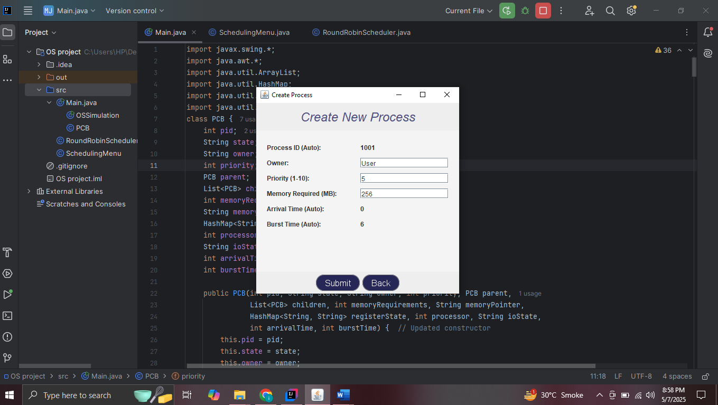**

**Task 2.2**

**Screenshot :**

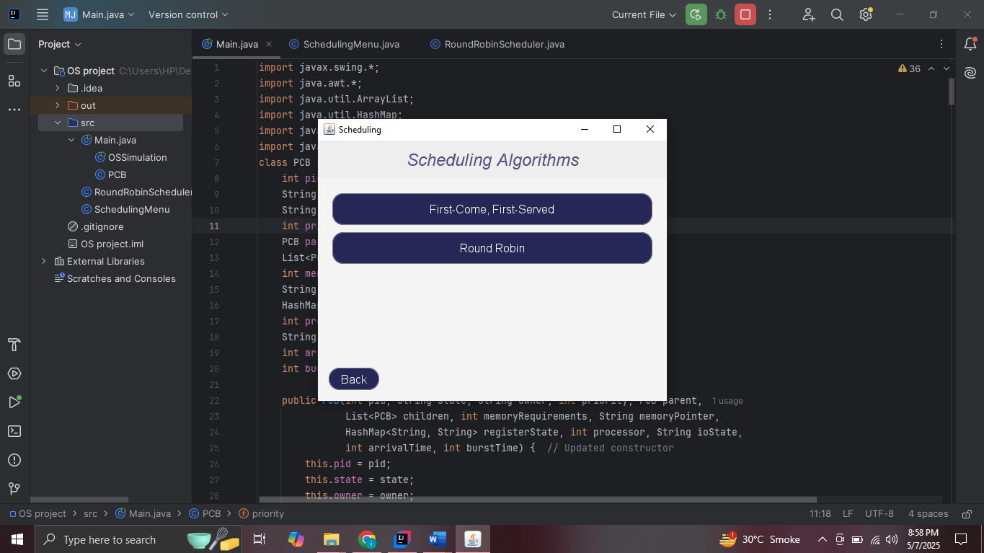

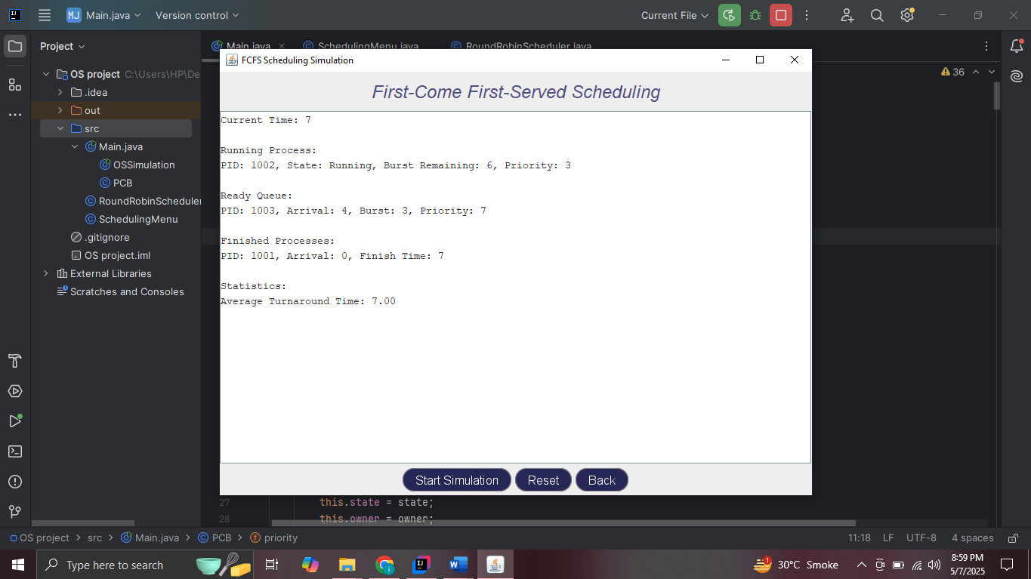

**Task 2.3**

